M E 365 Lab #5: Tension – Effect of Cold-Working and Process Annealing

Background
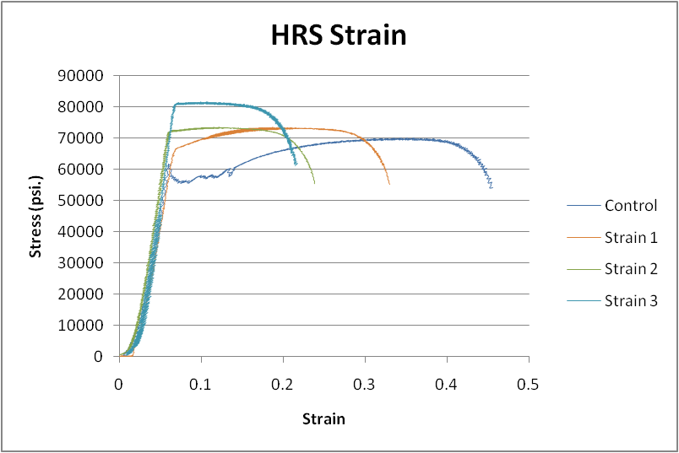
In a previous lab, we carried out a set of tensile and compression tests on various materials at ambient, sub-zero and elevated temperatures. One of the materials we investigated was the cold-rolled 1018/1020 steel, which was noticed to exhibit a brittle behavior at ambient temperatures, due to the introduced cold-work in the material. In this lab we will investigate the effects of cold working on material behavior using the simple tension test. Also, we introduce the concept of process annealing, and investigate its effects on relieving the material from the cold-work effects.
Cold working materials is a common process of inducing strain into a material while below the annealing temperature. The result is a material with higher yield strength, but reduced ductility. You will be testing a series of Type 304 stainless steel samples that have been exposed to various levels of cold strain.
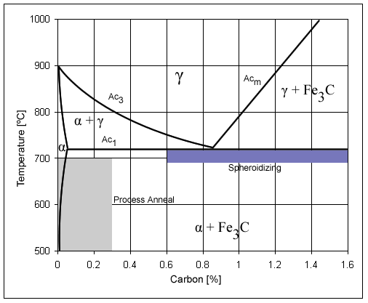
The figure below shows a typical phase diagram for carbon-steels, which describes the various phases of the material with a given percentage of carbon goes through, as the temperature changes. This diagram is essential for understanding and controlling the various heat treatments (annealing, normalizing, process annealing, spheroidizing, ….) that could be carried out on a given steel alloy. A portion of the lab will focus on process annealing; a treatment used to rid the material from the effects of cold work, enhancing its malleability, hence enabling it to undergo further deformation. In process-annealing, the material is heated to just below the ferrite-austenite temperature (Line Ac1 in the figure), and it is allowed to equilibrate for about 1 hour. The material is then cooled in air back to ambient temperatures. The material does not undergo any phase changes; the only change that occurs is the size/shape/distribution of grains.
In this lab, you will be stretching a set of cold-rolled 1018/1020 dog-bone specimens in the same manner you conducted the tensile test in previous labs. However, the specimens will undergo process annealing for varying times before testing, in order to familiarize you with the effects of annealing on the ductility of the material. You are expected to learn more about the other heat treatments in your MATSE 259 course.

Equipment and Materials
Instron 4465 Testing Machine
Data Collection Equipment
Dogbone samples (Type 304 Stainless Steel, Cold-rolled 1018 steel)
Furnace
Calipers
Safety Glasses
Gage Length Marker

Data Collection
The same process for data collection as described in Lab 1 will be used. Remember, there will also be displacement due to strain in the actual machine during the testing that will significantly skew the strain results.

Procedure
Use the same process to prepare the samples, testing equipment, and data collection computer as was used in Lab 1.
The Type 304 stainless steel samples have been exposed to 3%, 6%, or 10% strain.
The 1018 steel which had been obtained in the cold worked condition has been exposed to 1200ºF for times of 15, 30, 60 or 120 minutes annealing cycles.

Lab Report
Your group will need to submit a lab report for this lab. This report should follow the guidelines given in class. The report should detail how the cold-worked strain on the Type 304 stainless steel and the subsequent heat-treating on the 1018 steel affected the test results and the material properties (Yield Strength, Ultimate Strength, and Percent Elongation) observed through the test. Graphs of properties versus either percent cold strain or annealing temperature should be included. It should be noted that your group will be conducting only a subset of the total number of tests necessary for observing all the trends due to the changes in cold-working and heat treating time. Also, note that two tests were run for each condition, but only one is needed for the report. The duplicate runs are done in case a mistake is made on the first test. You may choose which run to use in your report. Once all the data has been collected, it will be posted on the course CANVAS site. You must submit your report on CANVAS.

M E 365 Materials Testing Laboratory

Testing Effect Matrix – Lab 5: Tension: Cold Work & Annealing

 |  | Material
 |  | Type 304  Stainless Steel |  | Steel (Cold-rolled)  AISI 1018
Effect | Value | Run 1 | Run 2 | Run 1 | Run 2
Control |  | 1 |  | 8
Strain Level 1 | 3% | 2 | 5
Strain Level 2 | 6% | 3 | 6
Strain Level 3 | 10% | 4 | 7
Annealing Time 1 | 15 min |  |  | 9 | 13
Annealing Time 2 | 30 min |  |  | 10 | 14
Annealing Time 3 | 60 min |  |  | 11 | 15
Annealing Time 4 | 120 min |  |  | 12 | 16

Steel Anneal Temp: 1200°F

